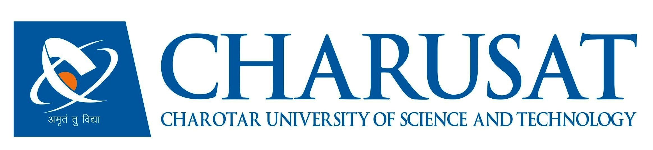 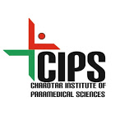

CHAROTAR UNIVERSITY OF SCIENCE AND TECHNOLOGY

FACULTY OF MEDICAL SCIENCES

CHAROTAR INSTITUE OF PARAMEDICAL SCIENCES (A Constituent of CHARUSAT)

DEPARTMENT OF MEDICAL LABORATORY TECHNOLOGY

A REPORT ON HANDS ON TRAINING AND PROTEOMIC WORKSHOP

IN SUPPORT WITH BIORAD LABORATORIES

8th – 11th AUGUST, 2018

Department of Medical Laboratory Technology from Charotar Institute of Paramedical Sciences (CIPS), a constituent of CHARUSAT has organized a four days hands on training on proteomics in support with BioRad Laboratories from 8th August- 11th August 2018. A total of twenty-nine (29) MSc. Medical Technology students participated and were benefitted with the training. The training program was specifically funded by BioRad.

The training started on 8th August, on the first day the students were introduced to the whole technique, bioinformatics software and the advantages/applications of proteomics. The BioRad person introduced one dimensional gel electrophoresis, 2 dimensional gel electrophoresis, Uniport, Swissport, etc. to students. The hands on training helped the students to perform the experimentation which is a part of their curriculum.

Day 1: The students were introduced to the 2 dimensional gel electrophoresis, MALDI, Instrument of 2 DE, 1 DE, online portals for identifying the proteins.

Day 2: Experimentation for 2 dimensional gel electrophoresis started and the students were made understand the whole procedure and all reagents and materials involved in the experimentation. The principle of all materials and reagents were explained in detail. The IPG strips were kept for rehydration and overnight incubation with sample.

Day 3: Amongst the two IPG strips one was stained and checked whether the strip has absorbed the sample or not and other strips were kept for iso electric focusing. Once the focusing was over it was washed with various reagents and stored at 4oC for further process.

Day 4: Second dimension of the strip was carried out on SDS PAGE and the protein from mixed protein sample was isolated. The personnel further explained that how to isolate the protein spot and by which method it is to be identified.

The four day hands on training was successfully accomplished with the help of Dr. Dhara N. Patel (Head and Assistant Professor, MT Dept.), Dr. Dhara Jajal (Assistant Professor, MT Dept.) & Mrs. Amita Patel (Teaching Assistant, MT Dept.) under the flagship of Dr. Darshan H. Patel (Principal, CIPS). Also, the effective commencement of the workshop would not have been possible without the BioRad personnels, Dr. Deepak Kumar (FAS, BioRad India) and Mr. Rahul Gandhi (Senior Account Manager, BioRad India). The budget for the same is attached herewith, which was used for light refreshment of the students and faculties involved.

Dr. Dhara N. Patel Dr. Darshan H. Patel

Head, MT Dept., CIPS Principal, CIPS

**Charotar Institute of Paramedical Sciences (CIPS)**

**CHARUSAT**

Light Refreshment expenditure for students, guests and faculties during four days workshop and hands on training on Proteomics- 2 Dimensional Gel Electrophoresis in association with BioRad. **The training program was specifically funded by BioRad.**

|  |  |  |  |
| --- | --- | --- | --- |
| **Sr. No.** | **Date** | **Details** | **Amount in INR** |
| 1. | 8th August 2018 | 2 Hot Coffee | 70 |
| 19 Tea | 190 |
| 1 Snack (Biscuits) | 30 |
| 2. | 9th August 2018 | 1 Hot Coffee | 35 |
| 20 Tea | 200 |
| 3. | 10th August 2018 | 1 Hot Coffee | 35 |
| 20 Tea | 200 |
| 4. | 11th August 2018 | 1 Hot Coffee | 35 |
| 20 Tea | 200 |
| **Total** | | | **995** |

Dr. Dhara N. Patel Dr. Darshan H. Patel

Head & Assistant Professor Principal

Dept. of Medical Technology, CIPS CIPS